LVM-Based Dynamic Storage Allocation System
for a Multi-User Server
Platform: Red Hat Enterprise Linux (RHEL) on Oracle VM VirtualBox
Date: August 16, 2026

AUTHOR:DHRUV GOSWAMI

1. Problem Definition & Scope

1.1 Problem Statement
Multi-user servers commonly run into a fundamental storage administration problem: fixed-size disk partitions cannot be resized without downtime, data loss, or complex migration once a user's allocated space runs out. Traditional partitioning schemes (MBR/GPT) bind a filesystem to a fixed, contiguous region of a single disk, so growing or shrinking user storage on demand is impractical.
This project addresses that problem by implementing a Logical Volume Manager (LVM) based dynamic storage allocation system, where per-user storage is provisioned as Logical Volumes (LVs) that can be resized live — grown or shrunk, and backed by more than one physical disk — without unmounting the server or repartitioning.

1.2 Scope
- Provision multiple virtual disks to a RHEL server running on Oracle VM VirtualBox.
- Aggregate the disks into a single Volume Group (VG) using LVM.
- Create independent, resizable Logical Volumes for two separate system users (user1, user2).
- Format, mount, and persist the storage using /etc/fstab.
- Demonstrate dynamic allocation: extending a Logical Volume's size and extending the Volume Group itself with an additional physical disk.
- Restrict access so each user can only access their own allocated storage.
The scope is intentionally limited to two demonstration users and does not cover quota enforcement, RAID redundancy, or encrypted volumes (LUKS) — these are noted as possible extensions in the Conclusion.

2. Design & Methodology

2.1 Design Overview
LVM introduces an abstraction layer between physical disks and the filesystems that use them, structured in three tiers:
- Physical Volume (PV) — a raw disk or partition initialized for use by LVM.
- Volume Group (VG) — a pool formed by combining one or more PVs; storage capacity is drawn from this shared pool.
- Logical Volume (LV) — a virtual partition carved out of a VG; this is what gets formatted and mounted, and can be resized independently of the underlying disk layout.
This layered design was chosen specifically because it decouples the user-facing storage (the LV) from the physical disk boundaries — additional PVs can be added to the VG at any time (vgextend), and that new space can be handed to any LV in the group (lvextend), which is exactly the dynamic-allocation behaviour a multi-user server needs.

2.2 Environment
- Hypervisor: Oracle VM VirtualBox
- Guest OS: Red Hat Enterprise Linux (RHEL), free developer subscription
- Disks: 1 boot/root disk (20 GB, pre-existing rhel VG) + 3 additional virtual disks (5 GB each: /dev/sdb, /dev/sdc, /dev/sdd) added specifically for this project
- Filesystem: XFS (RHEL's default filesystem)

2.3 Methodology / Planned Workflow
Stage | Command(s) Used
1. Disk provisioning | Add virtual disks in VirtualBox; verify with lsblk
2. Physical Volumes | pvcreate /dev/sdb /dev/sdc /dev/sdd
3. Volume Group | vgcreate vg_storage /dev/sdb /dev/sdc (sdd held in reserve)
4. Logical Volumes | lvcreate -L 3G -n lv_user1 vg_storage lvcreate -L 3G -n lv_user2 vg_storage
5. Filesystem | mkfs.xfs /dev/vg_storage/lv_user1 mkfs.xfs /dev/vg_storage/lv_user2
6. Mounting | mkdir -p /home/user1_storage /home/user2_storage mount /dev/vg_storage/lv_userN ...
7. Persistence | Add entries to /etc/fstab using UUID/device path
8. Dynamic growth | lvextend + xfs_growfs on lv_user1; vgextend vg_storage /dev/sdd, then lvextend on lv_user2
9. Access control | useradd, passwd, chown, chmod 700 per user

3. Implementation & Results

3.1 Disk Discovery and Physical Volume Creation
After adding three 5 GB virtual disks in VirtualBox, lsblk confirmed sdb, sdc, and sdd as raw, unformatted disks alongside the existing rhel volume group. Each disk was then initialized as an LVM Physical Volume.
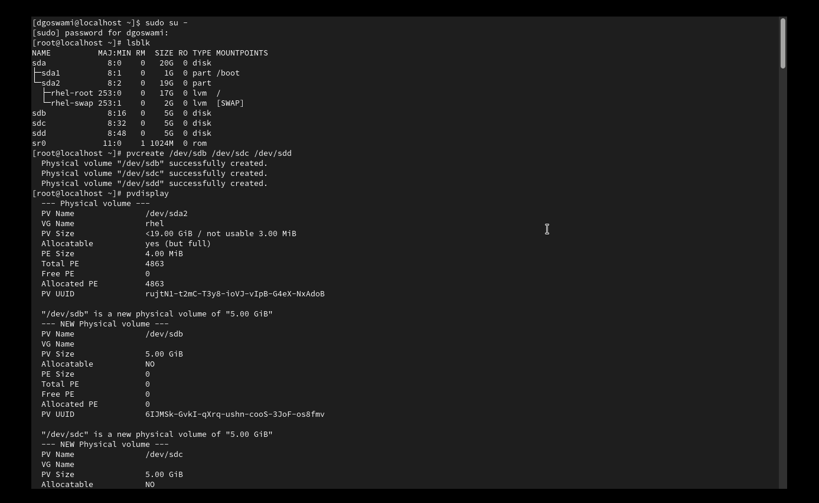
Figure 1: lsblk output showing new disks, followed by pvcreate and pvdisplay confirming all three disks as new Physical Volumes.
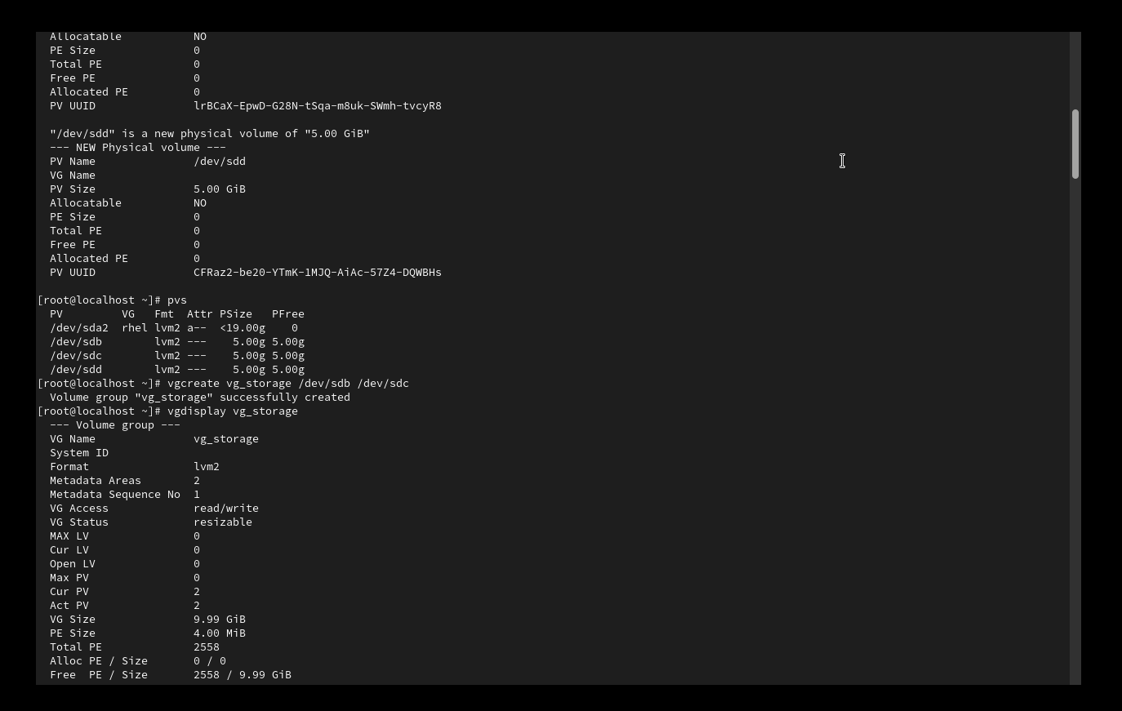
Figure 2: pvs summary of all four Physical Volumes; vgcreate and vgdisplay showing the new vg_storage Volume Group (9.99 GiB from two of the three disks).

3.2 Logical Volume Creation
Two Logical Volumes, one per user, were created inside vg_storage. An initial attempt used the volume name instead of the -n flag, which correctly failed with a Volume group not found error before being corrected.
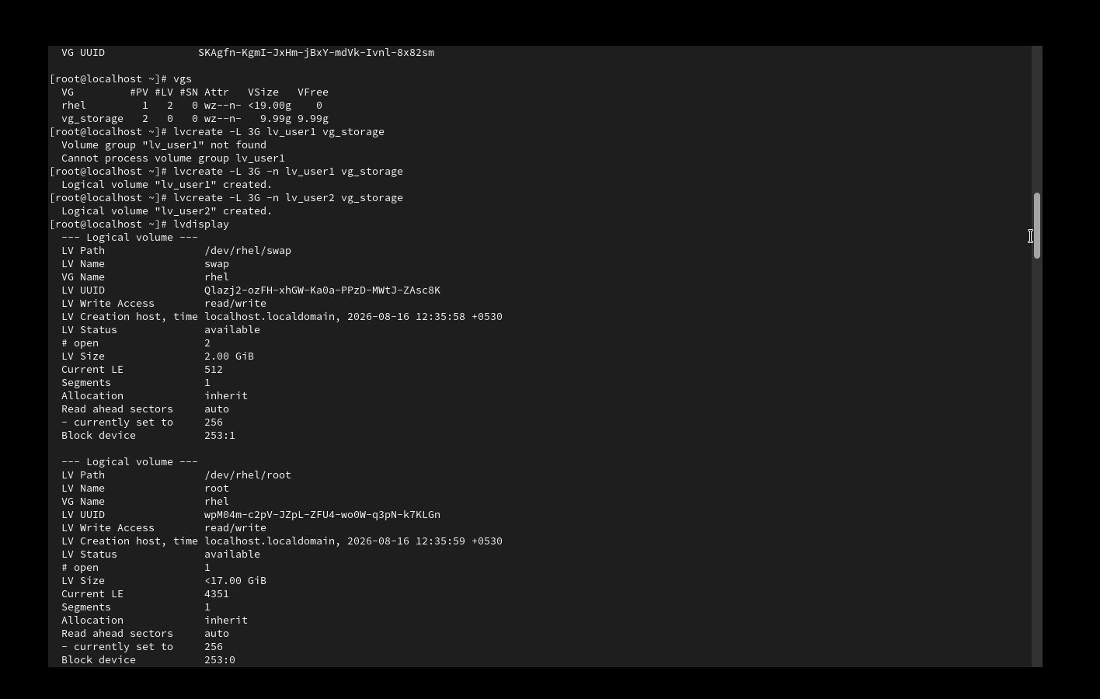
Figure 3: vgs summary, a corrected lvcreate command, and lvdisplay listing the pre-existing rhel/swap and rhel/root volumes.
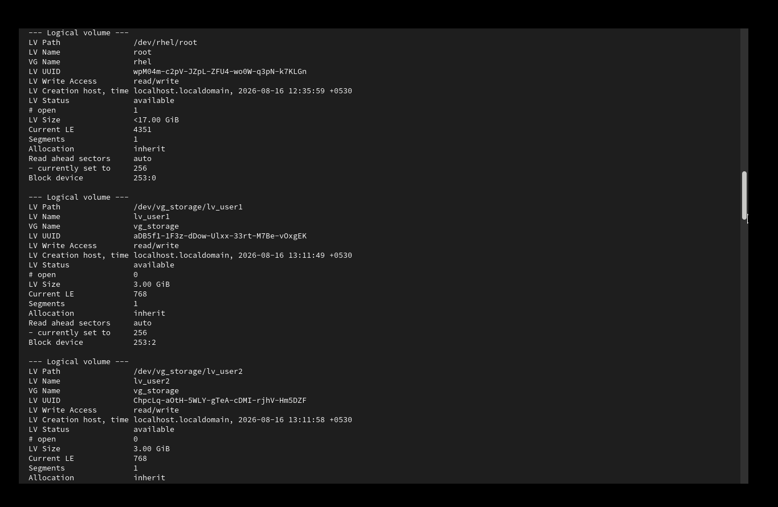
Figure 4: lvdisplay confirming lv_user1 and lv_user2, each provisioned at 3.00 GiB inside vg_storage.

3.3 Formatting, Mounting, and Persistence
Both Logical Volumes were formatted with XFS, mounted under dedicated directories, and verified with df -h.
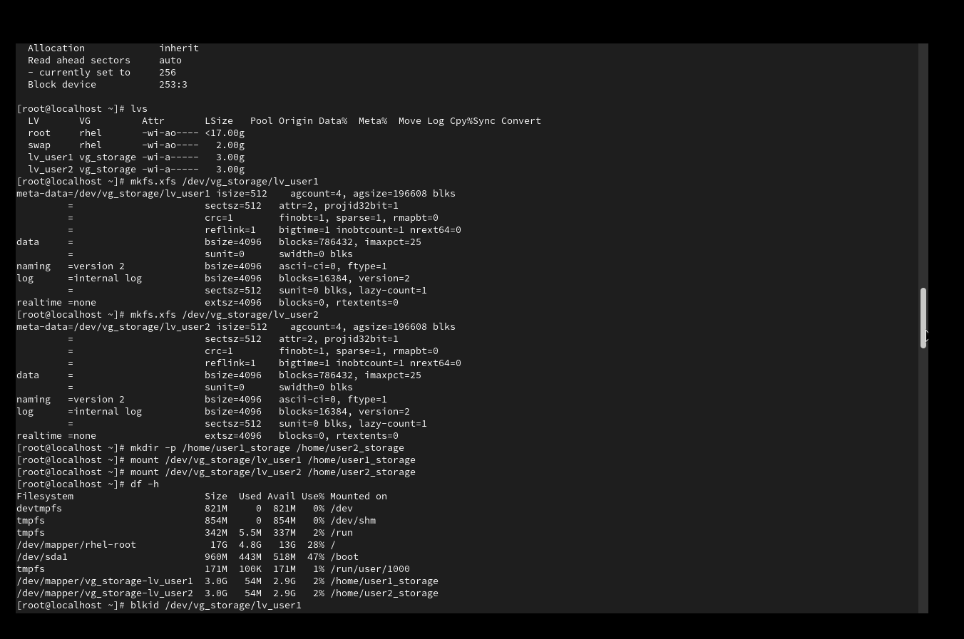
Figure 5: mkfs.xfs on both volumes, mount point creation, mounting, and df -h confirming ~3 GB available on each user's storage.
To make the mounts persist across reboots, entries were added to /etc/fstab. The first attempt introduced a formatting error — the intended six-field fstab line for each volume was accidentally split across multiple lines while editing in vi, producing four parse errors (lines 15, 16, 18, 19) and a failed mount of a literal "0" as a mount point.
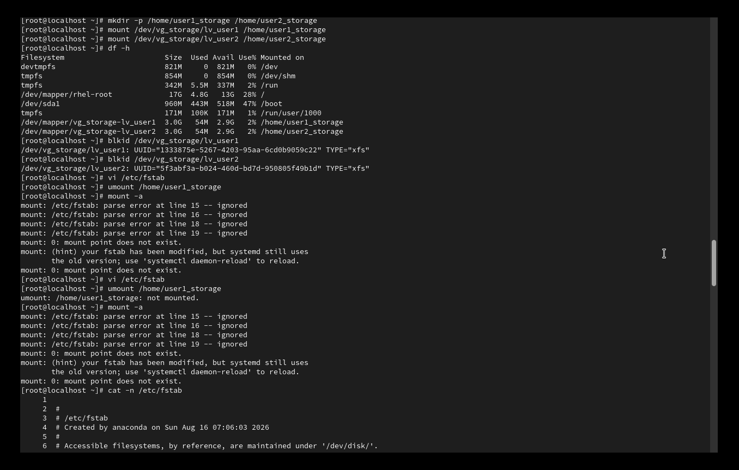
Figure 6: blkid output for both volumes, followed by the broken /etc/fstab entries causing repeated mount: parse error messages.
The broken lines were identified precisely with cat -n /etc/fstab, then removed with sed -i '15,20d' /etc/fstab and re-appended as single, well-formed lines using echo, each containing all six required fstab fields (device, mount point, filesystem type, options, dump, pass).
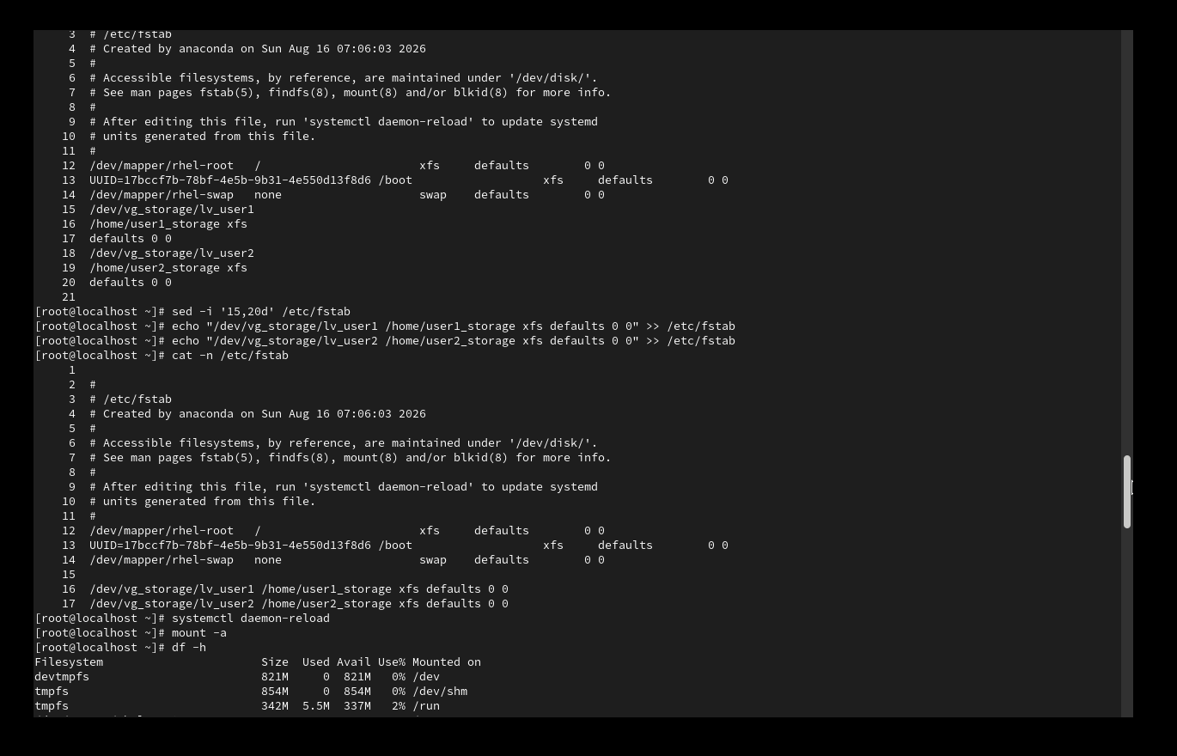
Figure 7: Diagnosis via cat -n /etc/fstab, the sed/echo fix, and mount -a completing with no parse errors after systemctl daemon-reload.

3.4 Dynamic Storage Allocation
With the base system working, the core objective of the project — dynamic resizing — was demonstrated in two ways: extending a Logical Volume within existing free space, and extending the Volume Group itself with a new disk before growing a second Logical Volume into that new space.
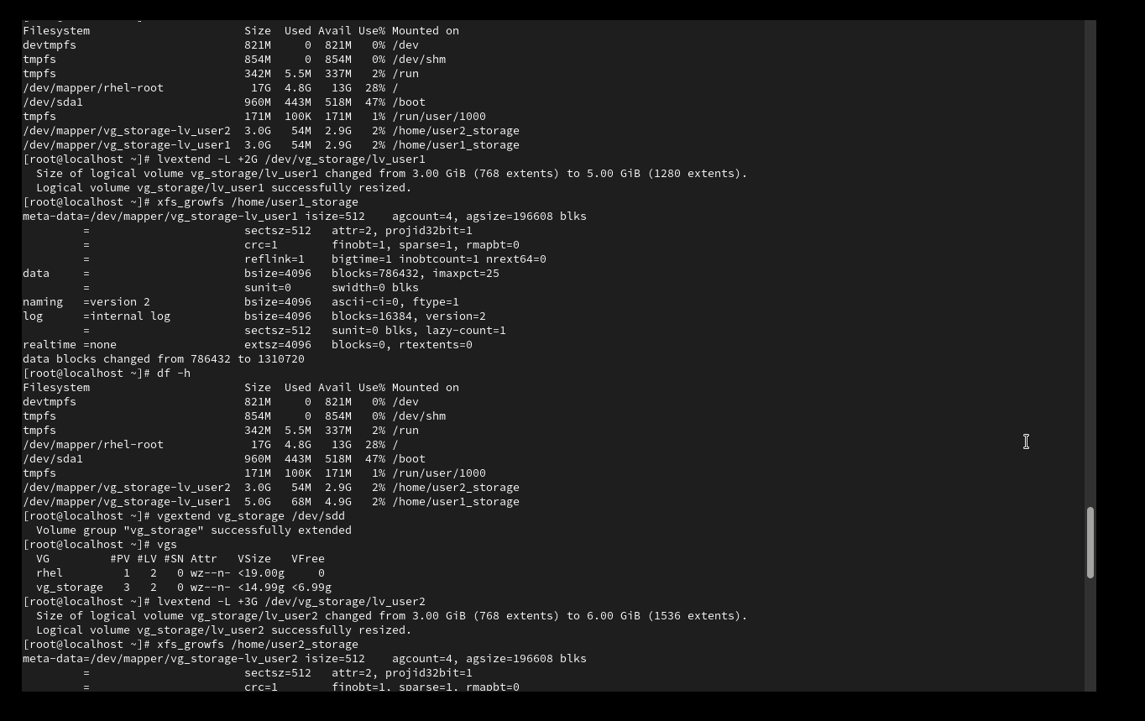
Figure 8: lvextend -L +2G on lv_user1 followed by xfs_growfs, growing it live from 3 GiB to 5 GiB with the volume mounted throughout; then vgextend vg_storage /dev/sdd adding the third disk to the pool, and lvextend -L +3G on lv_user2.
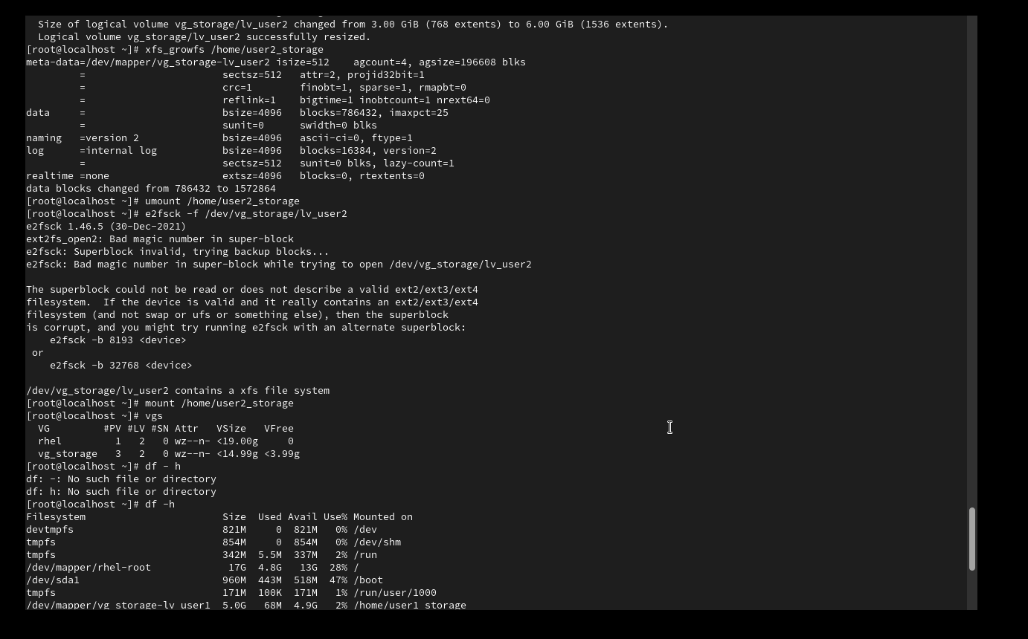
Figure 9: xfs_growfs completing the resize of lv_user2 to 6 GiB. An attempt to shrink lv_user2 via e2fsck failed because the volume is formatted as XFS, not ext-family — this is expected LVM/XFS behaviour and is discussed in Section 4.
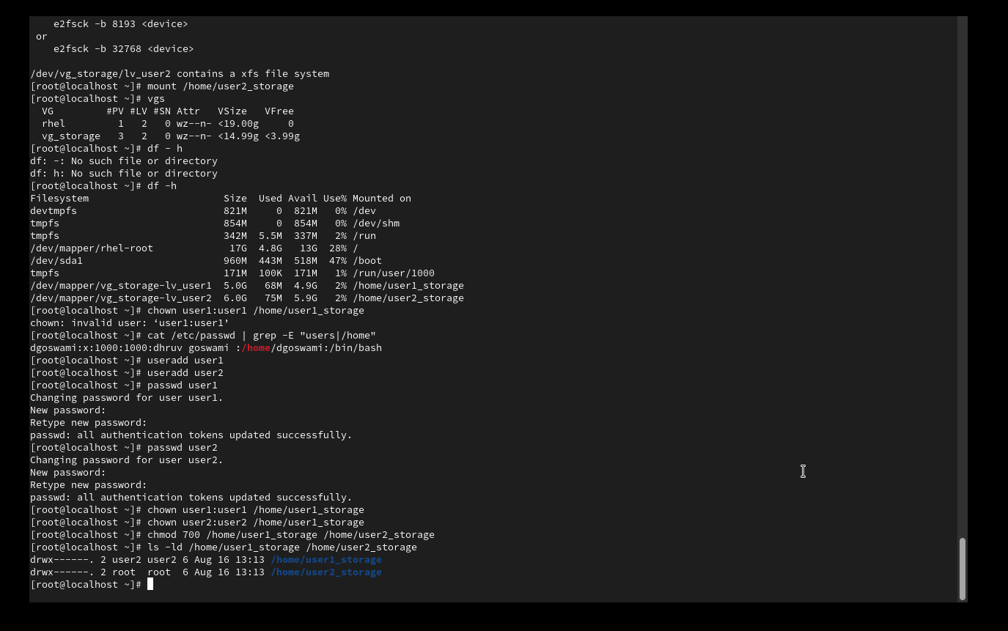
Figure 10: Final df -h showing lv_user1 at 5.0 GiB and lv_user2 at 6.0 GiB, each independently resized without unmounting the server or repartitioning any physical disk.

3.5 Per-User Access Control
Finally, the storage was tied to actual OS-level users so that each user's space is private. Two accounts, user1 and user2, were created with useradd and passwd, and ownership of each mount point was restricted to its respective user.

Figure 11 (continued from Figure 10): useradd, passwd, chown, and chmod 700 applied to both storage directories, with ls -ld confirming restricted (700) permissions.

4. Analysis & Interpretation

4.1 Results Summary
The final system state met the project's objective: two independently-provisioned, independently-resizable Logical Volumes back the storage for two separate users, drawn from a Volume Group that itself grew from two to three underlying physical disks without any service interruption. lv_user1 grew from 3 GiB → 5 GiB and lv_user2 from 3 GiB → 6 GiB, both while mounted and in use, which is the central proof that LVM decouples logical storage size from physical disk boundaries.

4.2 Issues Encountered and Root-Cause Analysis
- lvcreate -L 3G lv_user1 vg_storage failed with "Volume group 'lv_user1' not found" — the command syntax placed the LV name where a VG name was expected. Root cause: omitting the -n flag causes lvcreate to interpret the second bare argument as the VG, not the LV name. Corrected to lvcreate -L 3G -n lv_user1 vg_storage.
- /etc/fstab parse errors at lines 15–19 — each fstab entry must occupy exactly one line with six whitespace-separated fields. Editing in vi inserted unintended line breaks, splitting each entry into three fragments (e.g. the device path alone, then mount point + fstype, then options + dump/pass), which systemd-fstab-generator could not parse. Root cause: manual multi-line editing in a terminal-based editor is error-prone for structured single-line config formats. Fixed by deleting the broken range with sed -i and re-writing each entry as a single line with echo >>, which guarantees no accidental line splits.
- e2fsck -f on lv_user2 failed with "Bad magic number in superblock" during an attempted shrink. Root cause: e2fsck only understands ext2/ext3/ext4 filesystems, but lv_user2 was formatted with XFS. This is not a bug but a filesystem limitation — XFS does not support shrinking at all (by design, unlike ext4), so lvreduce cannot be used on it. Growing (xfs_growfs) works because XFS only supports online growth, never reduction.
- chown user1:user1 failed with "invalid user" — the Linux user accounts referenced in the design (user1, user2) had not actually been created yet; only the VM login account existed. Verified with cat /etc/passwd, then resolved with useradd and passwd for both accounts before retrying chown.

4.3 Interpretation
Most issues in this project were not LVM failures but interface and sequencing mistakes — command syntax, config-file editing, and forgetting a prerequisite step (creating the OS users before assigning ownership). This is a realistic reflection of real-world sysadmin work: LVM itself behaved predictably and safely at every stage (it refused ambiguous commands rather than guessing), and the errors were recoverable without any data loss, which is itself evidence of LVM's operational safety compared to raw partition resizing.
The XFS shrink limitation is a genuine architectural trade-off worth noting for the report: XFS was chosen (as RHEL's default) for its online-grow performance and stability, but a design that anticipates needing to shrink volumes would need to either use ext4 for those specific volumes or accept that shrinking XFS requires backup–reformat–restore rather than a live in-place operation.

5. Conclusion & Future Scope
This project successfully implemented and demonstrated an LVM-based dynamic storage allocation system on RHEL, meeting all objectives in the defined scope: multi-disk aggregation into a Volume Group, per-user Logical Volumes, persistent mounting, live resizing of both a Logical Volume and the Volume Group's underlying disk pool, and per-user access restriction.

5.1 Possible Extensions
- Enforce hard storage limits per user with XFS/ext4 quotas (in addition to LV size) so usage can be capped below the LV's full size.
- Add RAID-backed PVs (via mdadm or LVM RAID) for redundancy against single-disk failure.
- Encrypt Logical Volumes with LUKS for at-rest data protection on a shared server.
- Automate provisioning of new users' storage with a shell script wrapping lvcreate, mkfs, mount, fstab entry, and chown.

